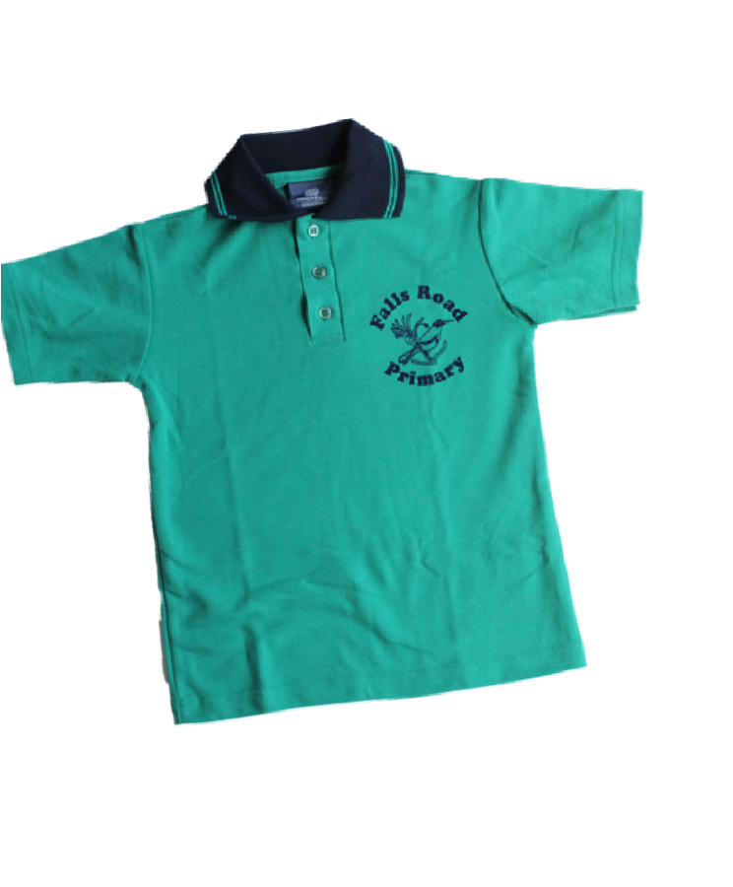
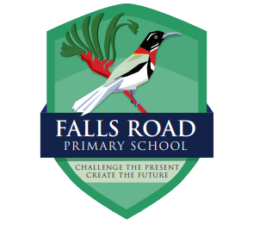

**UPDATED**

UNIFORM SHOP

OPEN HOURS 2024

All orders placed online from 29/01/2024 will be ready to collect within a week

Preferred method of ordering is online
http://www.fallsroadpandc.org.au/

Term 1 Open days 2024
Monday 29th January 11am - 1pm
Monday 5th February 8.20am - 8.50am
Monday 12th February 8.20am - 8.50am
Monday 19th February 8.20am - 8.50am
Monday 26th February 8.20am - 8.50am

You will be emailed when your order is ready to collect, please keep an eye on junk mail

